**SQL JOINS**

**Aim: Design at least 10 sql queries for suitable database application using SQL DML statements**

1. Create table Customers with schema (ID, name, age, address, salary)

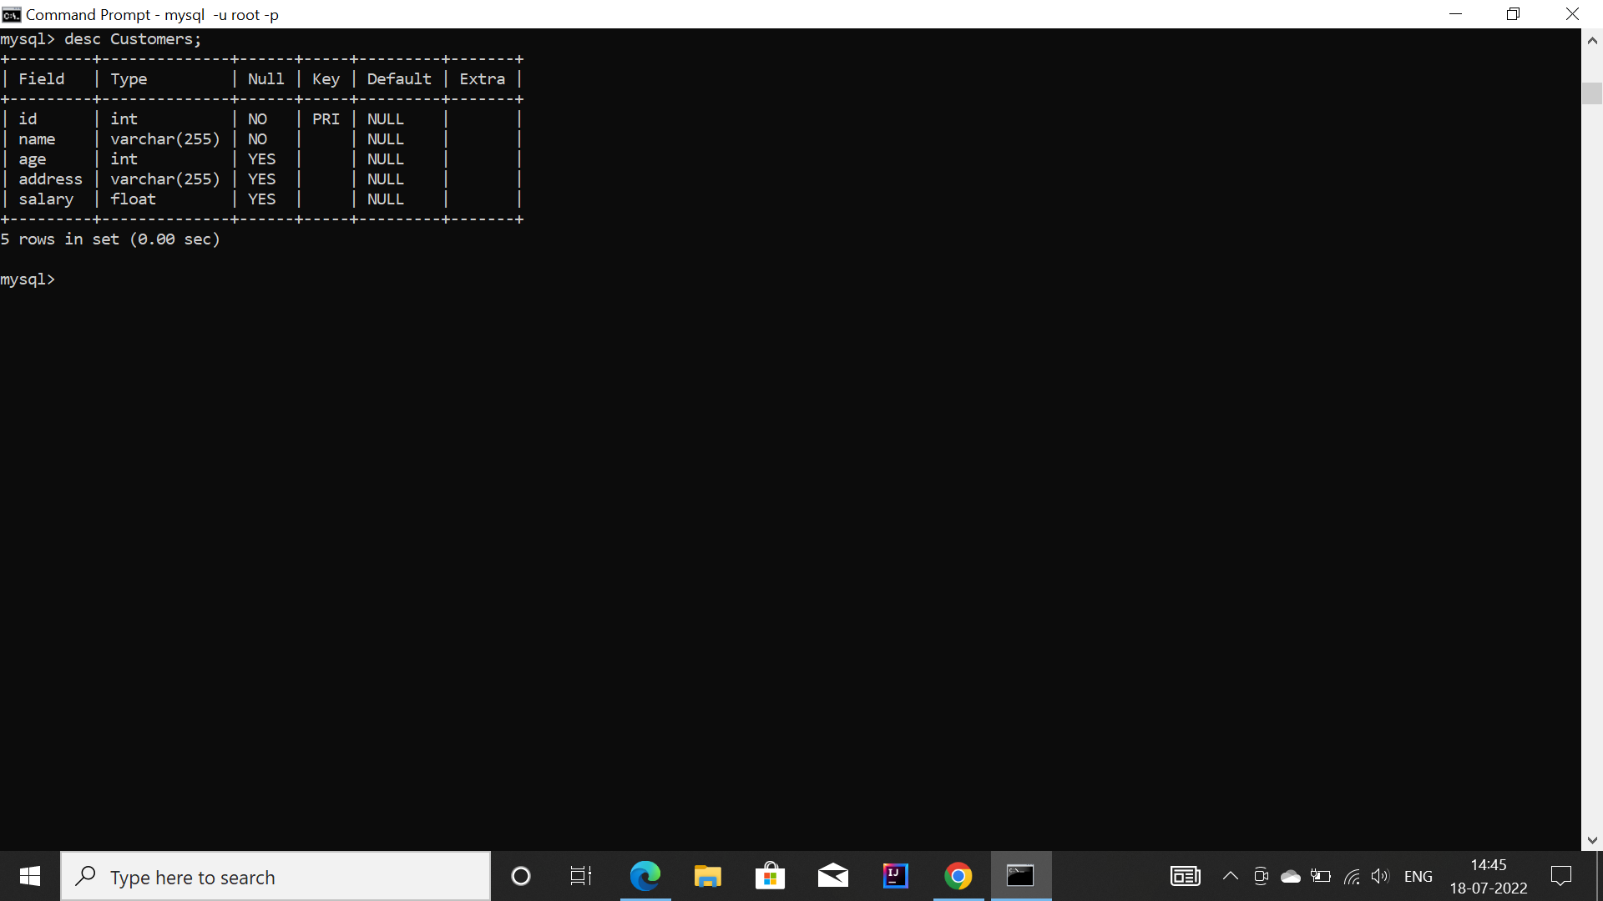

2. Create table Orders with Schema(O_ID, o_date, customer_id, amount)

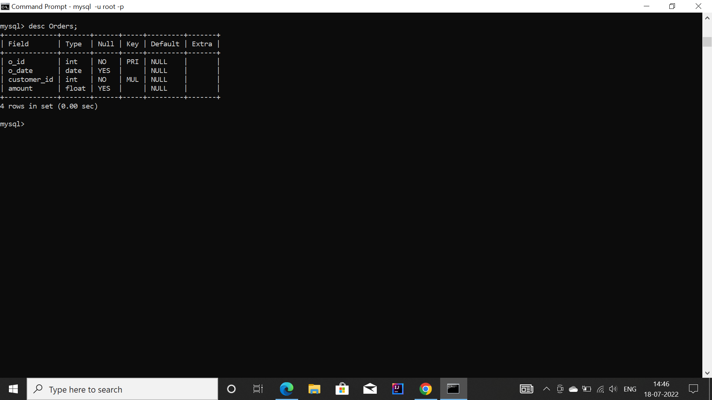

3. Insert 5 records to each table keeping few customer ids common to both the tables 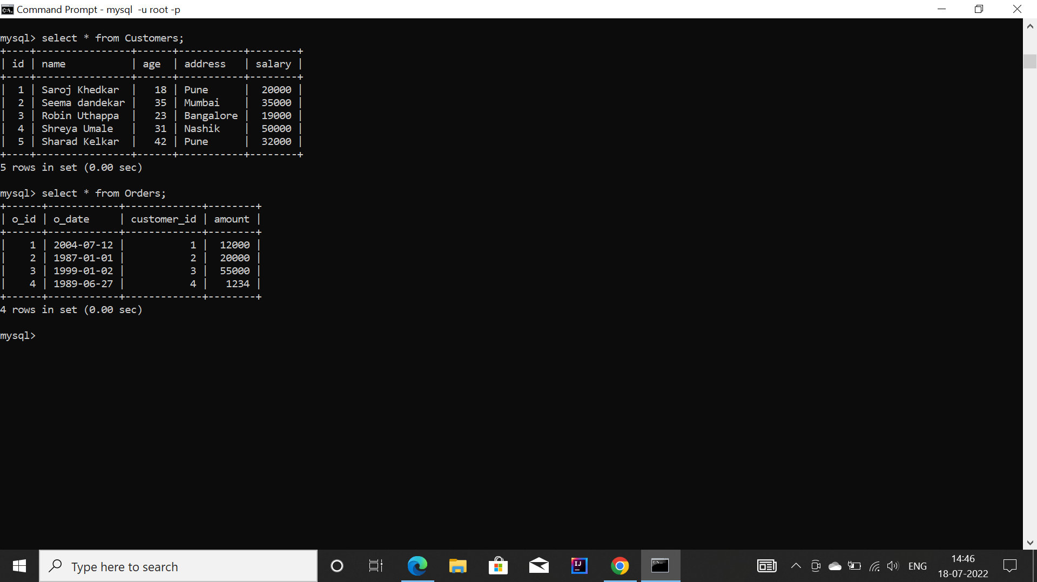

4. Perform the inner join on customers and orders table to enlist the id, name, amount and

O_date

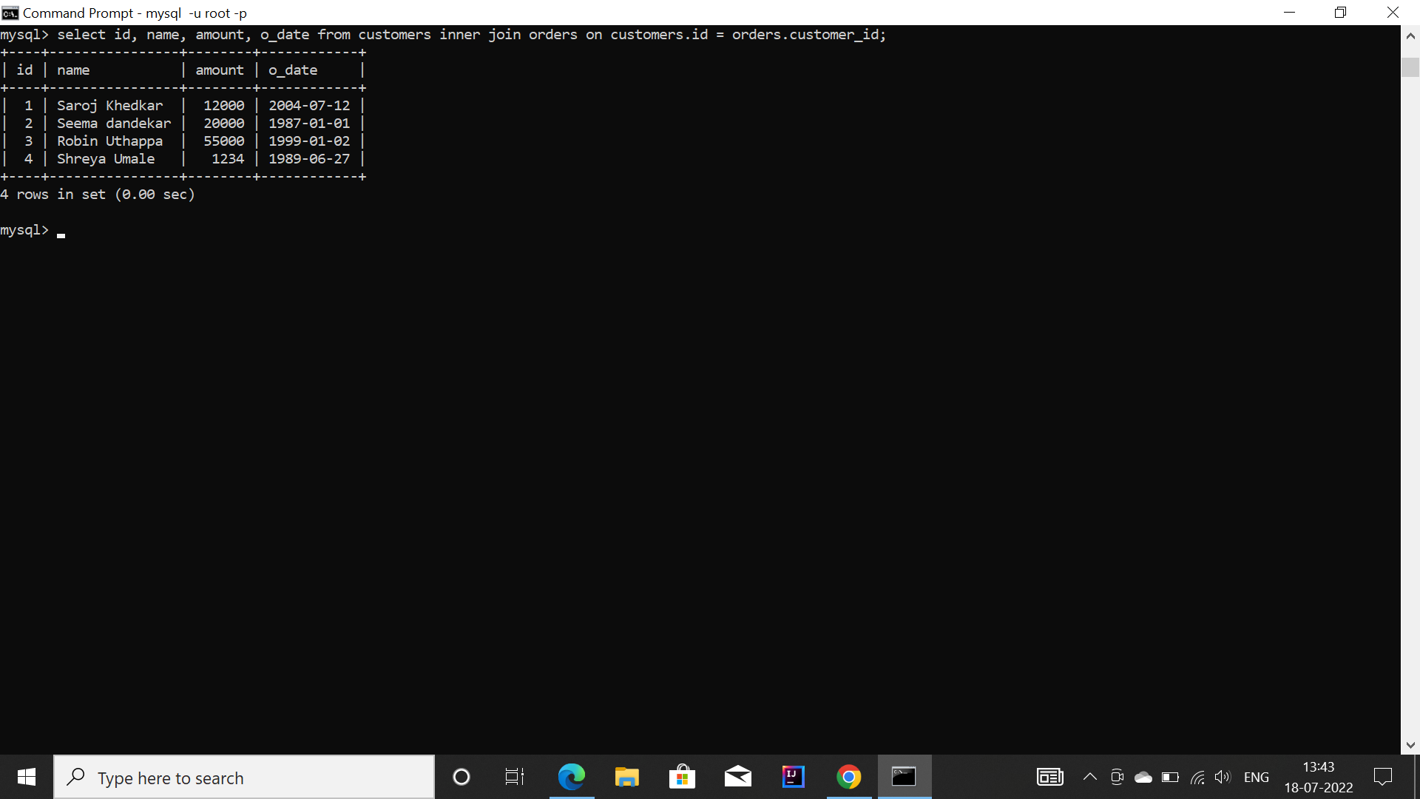

5. Perform the left outer join on customers and orders table to enlist the id, name, amount and o_date

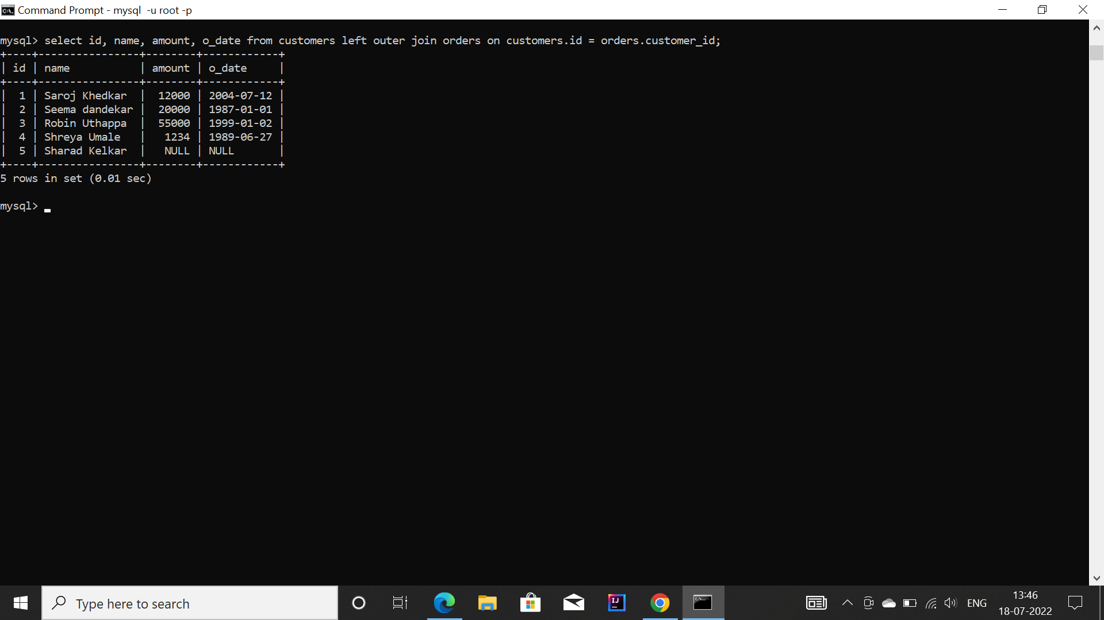

6. Perform the right outer join on customers and orders table to enlist the id, name, amount and o_date

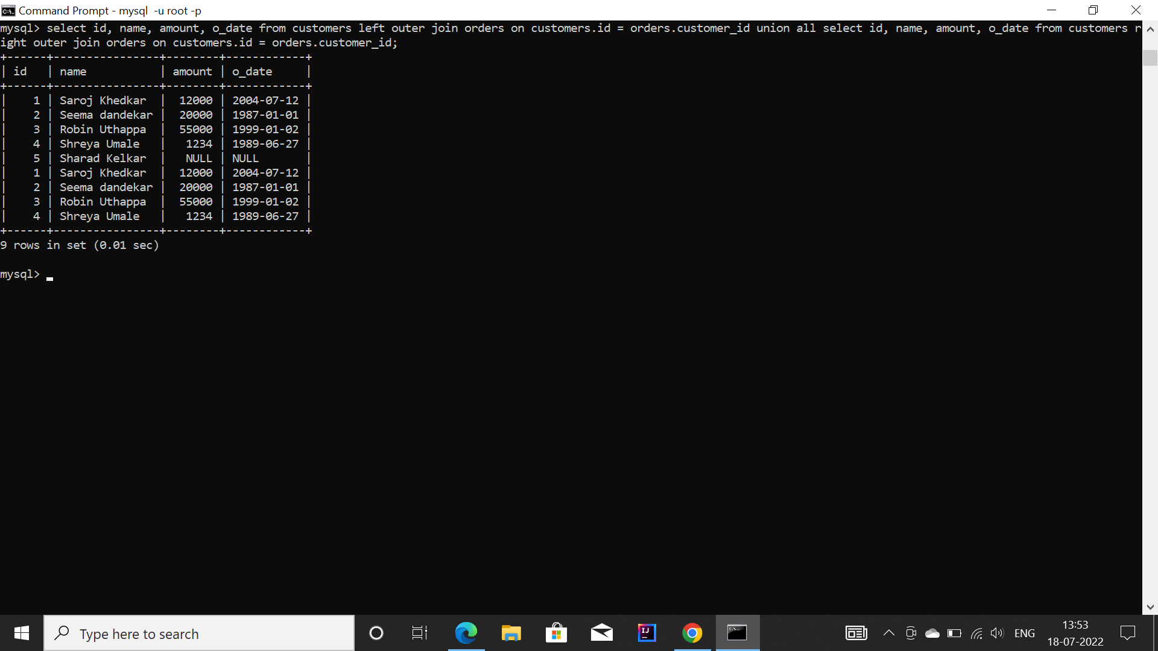

7. Perform the full outer join on customers and orders table to enlist the id, name, amount and o_date by using 'union all' set operation

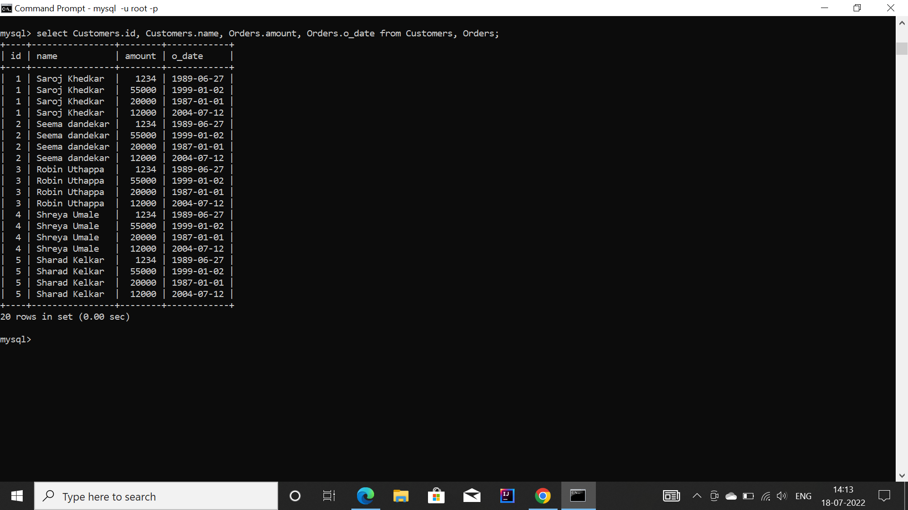

8. Perform the self join on customers table to enlist the pair of customers belonging to same

Address

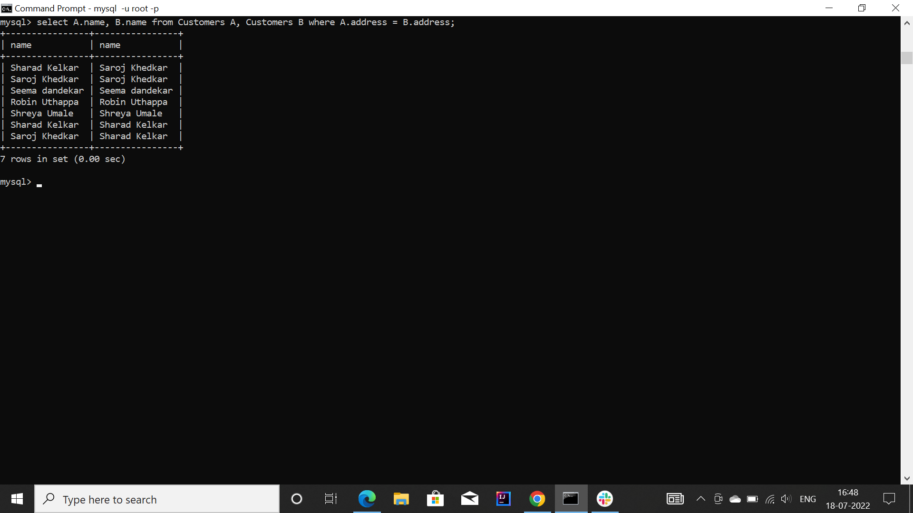

9. Perform the Cross/ Cartesian join on customers and orders table to enlist the id, name, amount and o_date



10. Design the sub query with select statement for displaying all the details of the customers having salary greater than 20000

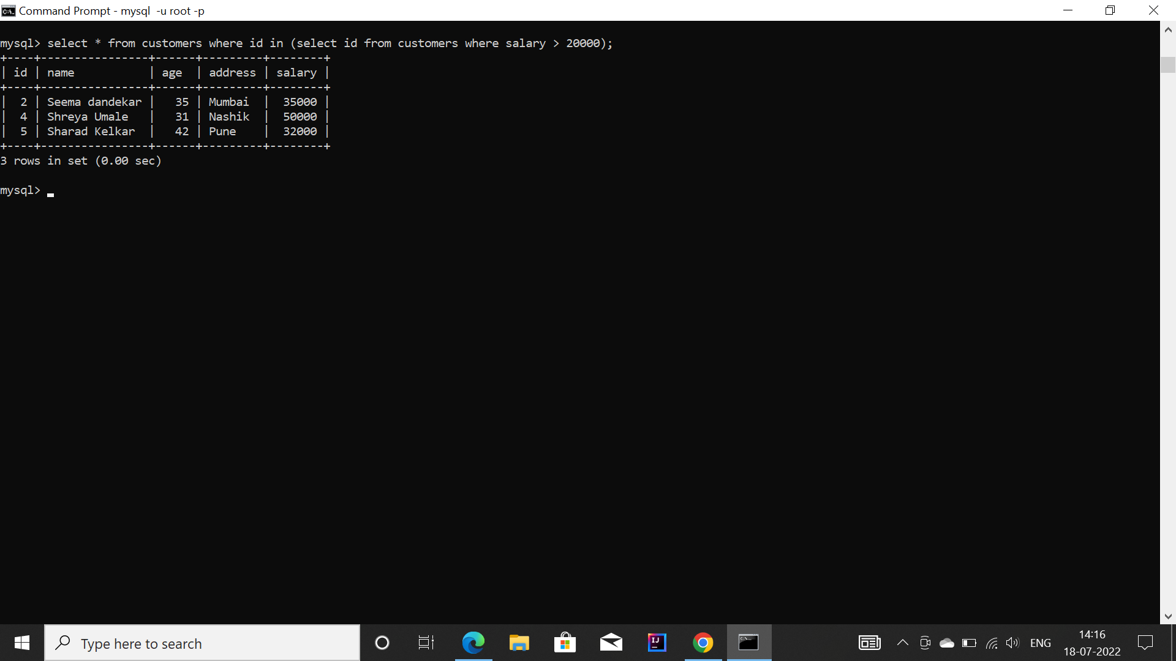

11. Create a backup table- 'cust_bkp' of the table customers by using insert statement

with the subquery

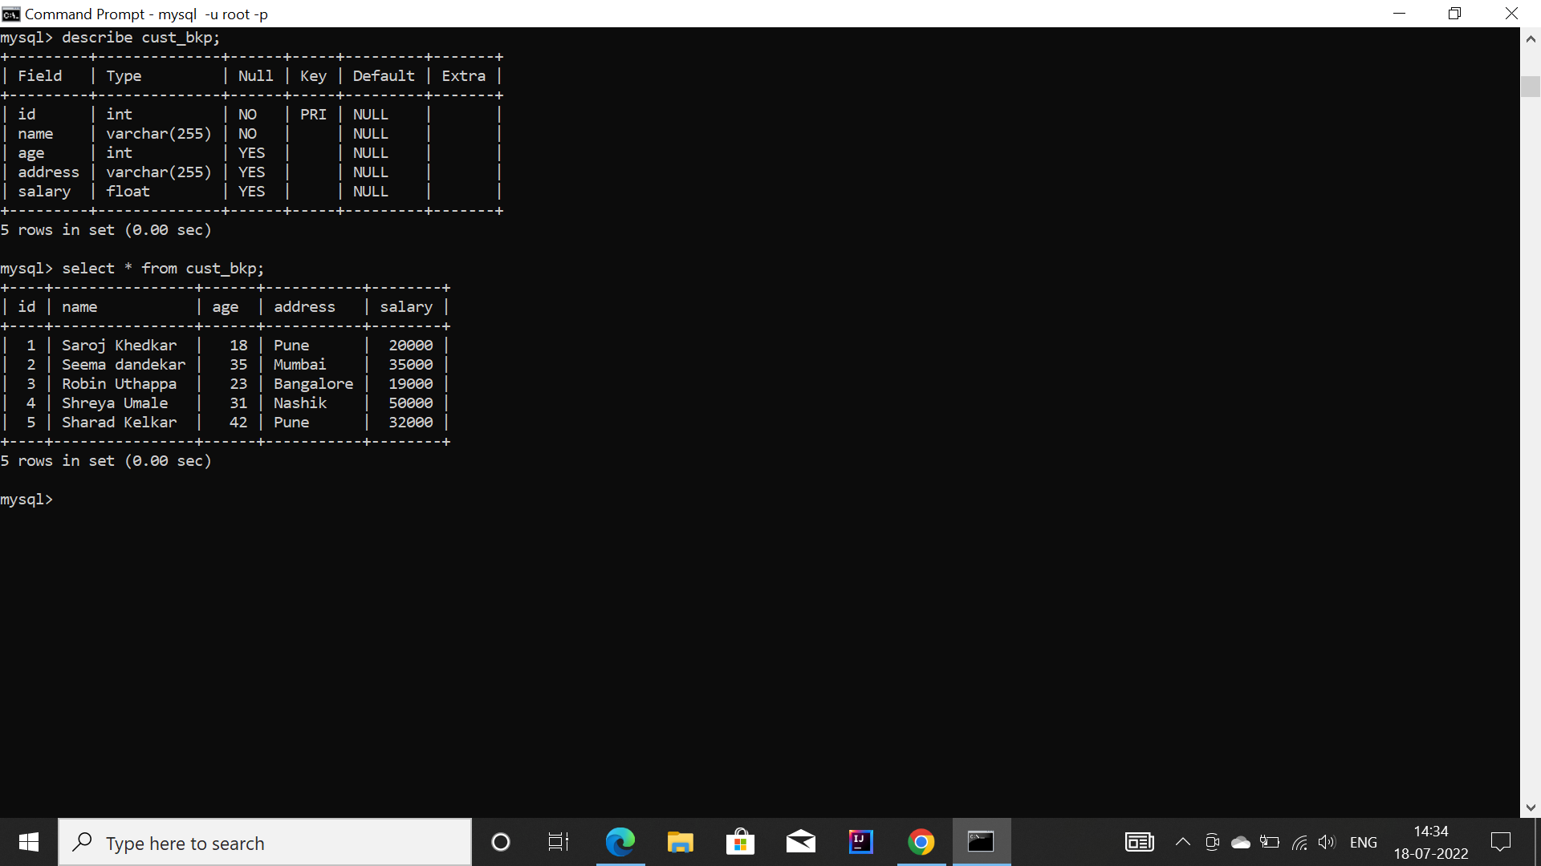

12. Update the salaries by 10% of all the customers(in customers table) having age greater than or equals to 24 by using subquery with update clause( by using backup table cust_bkp)

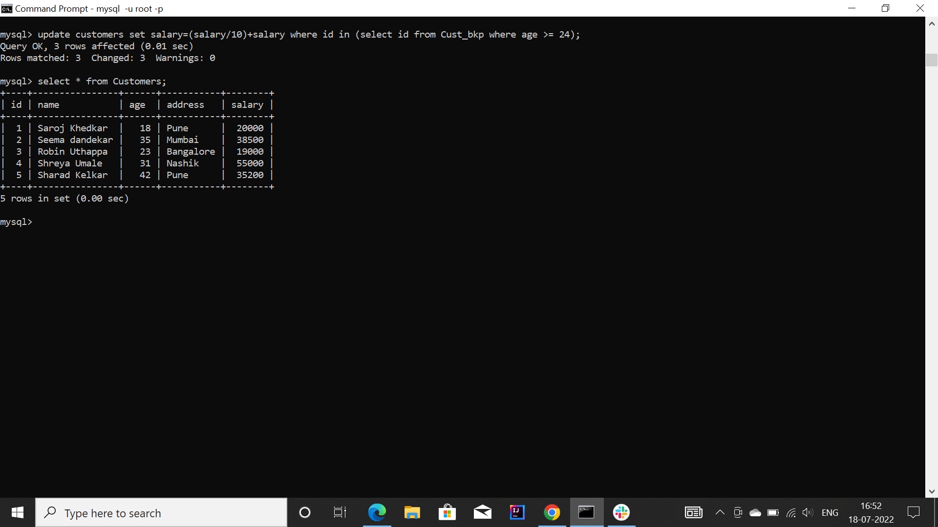

13. Delete all the customers having age greater than 26 by using delete clause with the subquery

